**SRI VENKATESWARA INSTITUTE OF TECHNOLOGY :: ANANTAPUR**

**Smart Interz**

**Name of the project : Estimation And Prediction Of**

**Hospitalization And Medical Care Cost**

**Class : 3rd year**

**Branch : C.S.E**

**TEAM MEMBERS**

**Team id: LTVIP2023TMID08316**

**Team size: 05**

**Team Members:**

**Team Leader : B.Naveenkumar**

**Team member : C. abhisarika**

**Team member : M iswarya**

**Team member : CHAKALI Vinaykumar**

**Team member : MAHENDRAKAR Tushar**

**Title of The Project**

**Estimation and Prediction of Hospitalization and Medical Care Costs**

* **Abstract**

Medical costs are one of the most common recurring expenses in a person’s life. Based on different research studies, BMI, ageing, smoking, and other factors are all related to greater personal medical care costs. The estimates of the expenditures of health care related to obesity are needed to help create cost-effective obesity prevention strategies. Obesity prevention at a young age is a top concern in global health, clinical practice, and public health. To avoid these restrictions, genetic variants are employed as instrumental variables in this research. Using statistics from public huge datasets, the impact of body mass index (BMI) on overall healthcare expenses is predicted. A multiview learning architecture can be used to leverage BMI information in records, including diagnostic texts, diagnostic IDs, and patient traits. A hierarchy perception structure was suggested to choose significant words, health checks, and diagnoses for training phase informative data representations, because various words, diagnoses, and previous health care have varying significance for expense calculation. In this system model, linear regression analysis, naive Bayes classifier, and random forest algorithms were compared using a business analytic method that applied statistical and machine-learning approaches. According to the results of our forecasting method, linear regression has the maximum accuracy of 97.89 percent in forecasting overall healthcare costs. In terms of financial statistics, our methodology provides a predictive method.

I

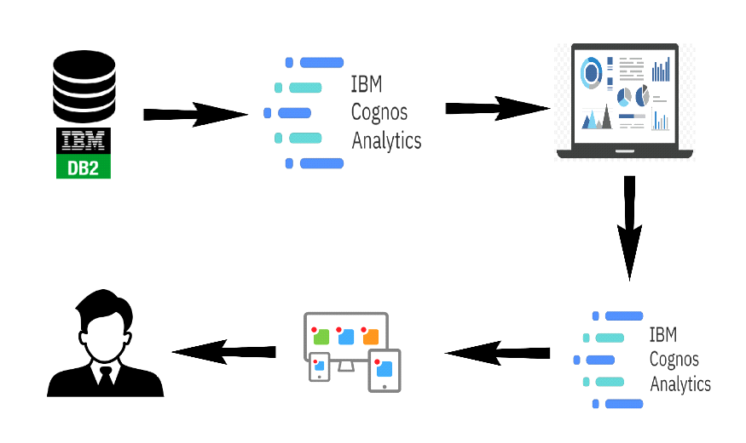

* Introduction

The incidence of overweight and obesity has increased significantly in most countries in recent decades. Excess weight is associated with an increased incidence of many chronic diseases, including vascular disease, respiratory disease, osteoarthritis, some cancer, type 2 diabetes, and premature death. There is consistent evidence that an increased BMI is associated with higher health costs, and these costs are expected to increase as obesity. Modelling uses machine-learning methods, in which the machine learns from the data and uses it to forecast new data [1, 2]. The most commonly predictive analytic model used is regression [3–6]. The proposed model for accurate prediction of future outputs has applications in banking, economics, e-commerce, sports, business, entertainment, etc. A method used to forecast healthcare costs for BMI is based on several factors. Multiple linear regression is one of the statistical techniques for estimating the relationship among the dependent (target) and independent variables. The regression method is commonly used to develop a system based on a number of factors to predict the cost.

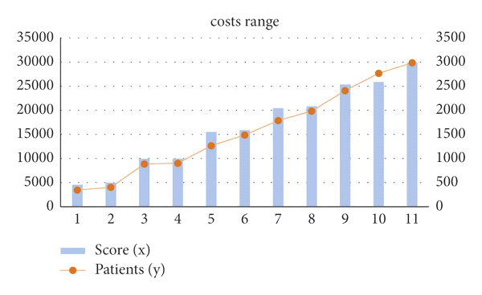

* **Graphic representation of cost range for patients’ score.**

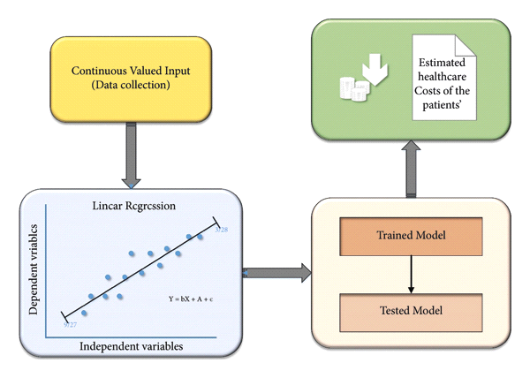

* **Block diagram for the proposed model.**
* **Results and Analysis**

The average annual rates and costs of consultations, tests, and prescription items were estimated by BMI category at the time of recruitment as shown in Figure 4. Percentage differences in rates and average annual costs were calculated for women with a BMI greater than 2 kg/m2 and a BMI greater than 20 kg/m2, both overall and according to the type of drug use. All models were evaluated using semi-possible generalized linear models with variations such as record link and Poisson. At the beginning of each year, annual expenses are estimated in subgroups defined by alcohol consumption, socioeconomic status, smoking level, educational qualifications, and strenuous exercise in recruitment [37]diversity of the proportional increases in annual costs among the types of each subgroup was estimated using the chis test.

* **Advantages of Estimation and prediction of hospitalization and medical care costs**

Estimation and prediction of hospitalization and medical care costs offer several significant advantages that contribute to better healthcare management and decision-making. Here are some of the key advantages:

* Resource Planning and Allocation
* Cost Containment
* Improved Patient Outcomes
* Optimized Revenue Cycle Management
* Evidence-Based Decision-making
* **Disadvantages of Estimation and prediction of hospitalization and medical care costs**

While the estimation and prediction of hospitalization and medical care costs offer numerous advantages, there are also several potential disadvantages and challenges associated with these practices. It is essential to recognize these limitations to ensure that the models are used appropriately and their results are interpreted with caution. Some of the disadvantages include:

* Data Quality and Availability
* Complexity and Interpretability
* Inherent Uncertainty
* Ethical Considerations
* Overfitting and Generalization
* Changing Healthcare Landscape

**Conclusion**

In conclusion, the estimation and prediction of hospitalization and medical care costs are valuable tools that offer both advantages and disadvantages in the healthcare industry. These practices play a crucial role in healthcare management, resource allocation, and policy decision-making. By leveraging historical data and employing advanced analytical techniques, healthcare providers and policymakers can gain valuable insights into healthcare costs, identify cost drivers, and make informed decisions to optimize patient care and financial sustainability.

The advantages of cost estimation and prediction include improved resource planning and allocation, cost containment through risk stratification and preventive measures, enhanced patient outcomes through personalized care, evidence-based decision-making, and support for health insurance planning and public health initiatives. These advantages contribute to a more efficient and effective healthcare system, benefiting patients, healthcare providers, and the broader community.

Moving forward, ongoing research, innovation, and improvements in data collection, integration, and modeling techniques will lead to more accurate and reliable cost estimation and prediction. By using these tools responsibly and in tandem with human expertise, the healthcare industry can continue to improve patient outcomes, optimize resource utilization, and advance the goal of accessible, affordable, and high-quality healthcare for all.

**SRI VENKATESWARA INSTITUTE OF TECHNOLOGY :: ANANTAPUR**

**Smart Interz**

**Name of the project : Estimation And Prediction Of**

**Hospitalization And Medical Care Cost**

**Class : 3rd year**

**Branch : C.S.E**

**TEAM MEMBERS**

**Team id: LTVIP2023TMID08316**

**Team size: 05**

**Team Leader : B.Naveenkumar**

**Team member : C.abhisarika**

**Team member : M iswarya**

**Team member : CHAKALI Vinaykumar**

**Team member : MAHENDRAKAR Tushar**